Project Group 05

Project Management Plan

Authors: bmo; sr11; hac22; wia2;

wjl3; njv1

Config Ref: SE_05_TS_01

Date: 11/11/13 Version: 2.0 Status: Release Department of Computer Science

Aberystwyth University

Aberystwyth, Ceredigion

SY23 3DB

Copyright © Group 05

Aberystwyth University 2013

Contents

1. Introduction 3

1.1. Purpose of this document 3

1.2. Scope 3

1.3. Objectives 3

2. Overview 4

2.1. Platforms and high level architecture 4

2.2. Target user base 4

3. Use case 5

3.1. Android Use Case 5

3.2. Descriptions of the Android Use Case 6

3.2.2. Settings 6

3.3. Web Side Use Case 7

3.4. Description of the Web Side Use Case 8

4. Android User Interface Design 9

4.1. Main Screen 9

4.2. About screen 9

4.3. Map screen 9

4.4. User Navigation 10

5. Website User Interface Design 11

5.1. Home Page 11

5.2. Map page 11

5.3. About page 11

5.4. Overview 11

6. Gant Chart 12

7. Risk Assessment 13

8. References 14

9. Document History 14

1. Introduction

## Purpose of this document

The purpose of this document is to show how the project group has decided to carry out the client’s   requirement specification for a walking tour application as a set of objectives and milestones.

* 1. Scope

This document contains the details of the group project. It contains the group’s choice of platforms and high level architecture as well as justification for the choices made. The Use-Case diagram is included showing how different users will interact with the different parts of the system as well as screenshots and descriptions of the GUI. The proposed Gantt chart is part of this document, detailing what the group will be working on in the process of development and in what timeframes.

* 1. Objectives

The objectives of this document are as follows:

* + 1. To describe the overview of the proposed system;

### To describe how the main components of the system will interact with each other;

### To present the base user interface and describe how the user will interact with it;

### To provide a list of the project milestones;

### To provide a list of all tasks that need to be completed on the project and their anticipated timeframe in the form of a Gantt chart;

### To list possible issues the team might encounter during development in the form of risk analysis.

1. Overview

The proposed system is a walking tour android application that allows people to “record” walks they make through GPS and add information and pictures at points they find something interesting. The walks will be available to view on a website for everyone.

## Platforms and high level architecture

### Android

The platform has been specified by the client in the project guideline.

### IDE

We are using the Eclipse IDE with the ADT plugin because that is the IDE the team is most familiar with. We took into account Android Studio but reached the conclusion that Eclipse was more stable provided a better user interface.

### Android Mapping API

We are using Google Maps for the Android mapping API because it comes as part of the Android SKD and gives the user a full screen map to view, which the programmer can overlay with their own controls. This extends the FR8 requirement in the requirement specification document [1] to allow for the user to view the map on their android device.

### PHP

The research showed that PHP is capable of processing easily JSON files, which we will be using, also it is available on most servers and is currently taught in one of the second year modules.

### JSON

JSON would be the best data set to use for sending the information about the recorded walk to the server. This is largely due to it being significantly lighter in weight than XML and how easy it is to process in PHP.

### Web side mapping API

Because of its wide variety of browser support, features and simplicity, the Leaflet API stood out as exactly what the project group would need to use.

## Target user base

The client has suggested second year computer science students as target base, but the app is not targeted specifically at that user group. Its purpose can be different for different users thus making it usable in a variety of ways and the actual system has to be easy to use by most age/background groups

# Use case

## Android Use Case

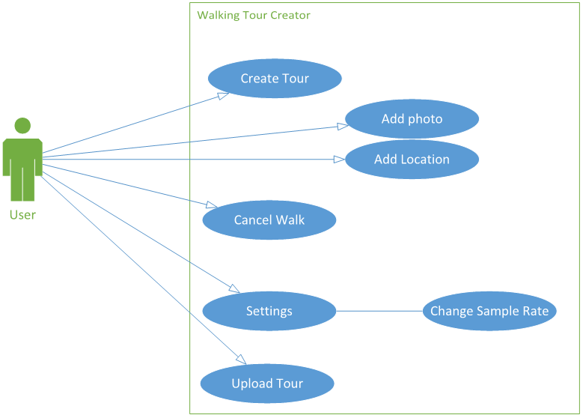

## Descriptions of the Android Use Case

### Create Tour:

This will allow the user to create a new walking tour, regardless of logging in to our servers or not the user will be asked to select a title for their tour and a short description (as minimal) before starting the tour, during the tour they can attach photos of local scenery and the like with a short description of the photo.

### Add Photo:

This will use the built-in camera app on the android device to take a photo for the user to add to their walk.

### Add Location:

This will get called periodically to allow for an accurate walking tour to be created.

### End Walk:

When the user presses to end the tour, they will be given a summary of the tour, and be asked to fill in the missing long description (if they did not do so before creating the tour), they will then be prompted to see if they want to have the walk saved locally or uploaded straight away.

* + 1. Settings:

This is where the user will give their preferences for different in app options, such as the upload option, if a user is concerned about their data limits they can choose to only upload over Wi-Fi.

### Log in:

This is where members of the website can sign in to have the walks they create attributed to them. Possibly the user could edit the notes on their walks from previous uploads although this isn't in the specification.

### Upload Tour:

If the user has chosen to save their tours locally on the device, this option will allow the user to select which tours they wish to upload to the website.

## Web Side Use Case

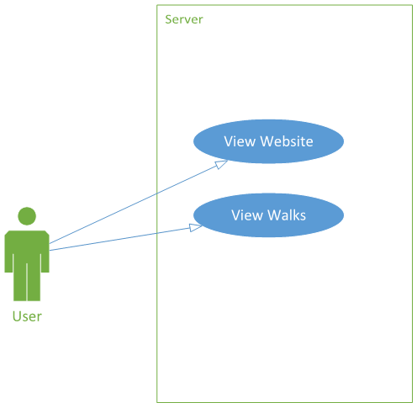

Log i

## Description of the Web Side Use Case

### View Website

Displays our walking tour viewer homepage.

### Database Dependent Use Cases

### Manage Walks

Allows the user the ability to edit/delete previous walks on their profile.

### View Tour:

This will display a map for the user to view with "pins" in it that have pictures attached along with the notes associated with the walk.

### Create New User:

Creates a new user account, minimum requirements are e-mail address, username, and password. Other data can be held, for example in an extended profile.

### Search Walks:

Searches based on keyword/location and delivers the top “x” amount of walks.

### Receive Tour:

Takes a MIME file sent from the app, decodes it and stores the information in a

SQL database.

# Android User Interface Design

The following wireframes are initial concept for the design and will be modified accordingly with time.

## Main Screen

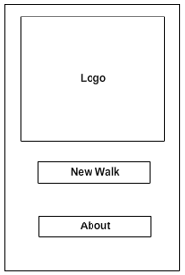

On the main screen the user can see whether he is logged in or not. The start button will take the user to the preparation screen for a recording where they can add descriptions and a title for the walk.

The settings and Info buttons take the user to the specified sub-screen.

## About screen

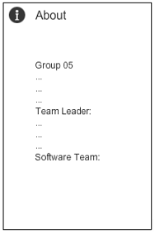

This screen displays information on the app such as version, development team and so on. The user will be able to get contact details for the group from there.

## Map screen

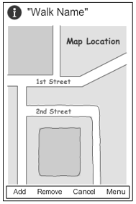

On the map screen the user will see his position on the map and the path that he has already walked on. They can use the add photo button to select/take a photo and add a description to it. The cancel walk will exit the walk without saving it.

## User Navigation

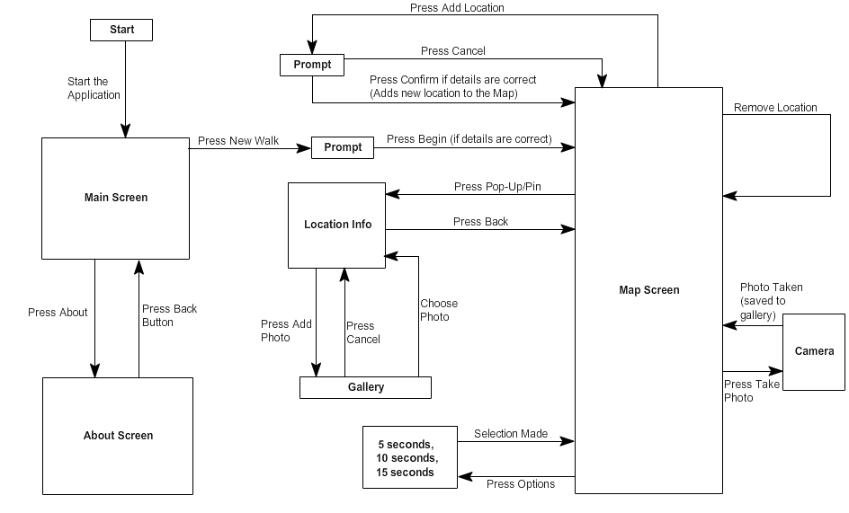

# Website User Interface Design

## Home Page

## Map page

## About page

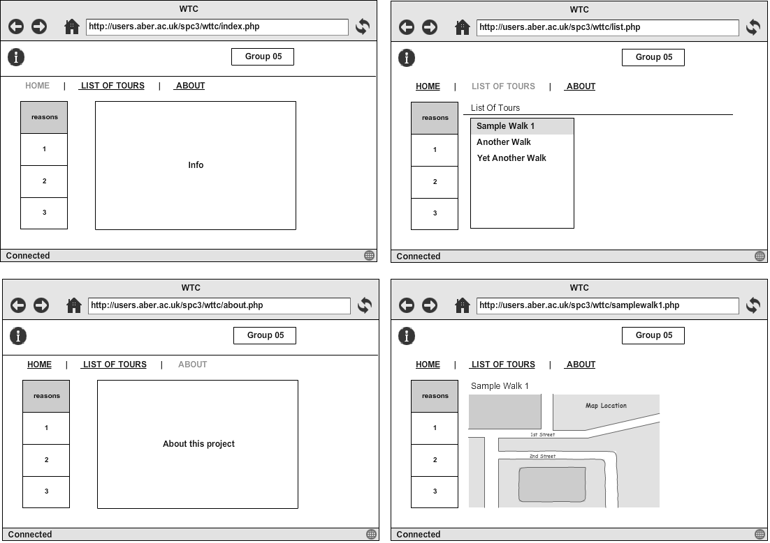

## Overview

The site will consist of 3 main pages. The home page, where the user can see information about the project, view a tutorial on how to use the website and navigate further. The map page, where a user can load and view a walk that is in the database. The about page where the project group’s contacts are listed so that users can give feedback to us about the site.

# Gant Chart

# Risk Assessment

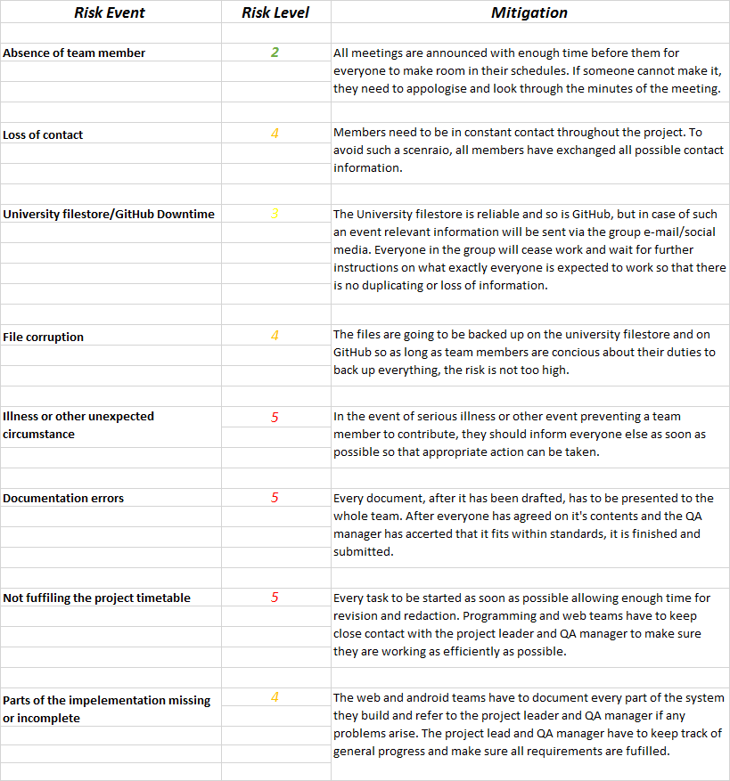

|  |  |  |  |  |  |
| --- | --- | --- | --- | --- | --- |
| **Risk Level** | ***2*** | ***3*** | ***4*** | ***5*** | ***6*** |
| **Consequences** | ***Low*** | ***Low/Med*** | ***Med*** | ***Med/High*** | ***High*** |

# References

[1] QA Document SE.QA.RS –Requirement Specification.

# Document History

|  |  |  |  |  |
| --- | --- | --- | --- | --- |
| Version | CCF No. | Date | Changes Made to the Document | Changed by: |
| 1.0 | N/A | 06/11/2013 | N/A – First release of project plan | srr11 |
| 1.1 | N/A | 06/11/2013 | Changed the Web Side Use Case | bmo |
| 1.2 | N/A | 03/12/2013 | 2.1.3 - Referenced requirement specification document.  2.1.5 - Added where JSON is being used.  4.2 - Removed the log in and delete walk feature.  4.4 - Removed subsection entirely. | njv1 |
| 2.0 | N/A | 28/01/2013 | Updated information about the project and methodologies used in development, updated wireframes for the android app and the website, updated the UML Use-Case diagrams for both platforms. | srr11 |